**Job Portal Project**



A Project submitted to the

Department of Computer Science and Engineering,

Hajee Mohammad Danesh Science and Technology University

Course Title: Software Engineering

Course Code: CSE 305

Submitted To,

Pankaj Bhowmik

Lecturer

Department of Computer Science and Engineering

Submitted By,

Rafia Tusnim Oeshi

Student ID: 2002074

Level 3, Semester I

DEPARTMENT OF COMPUTER SCIENCE AND ENGINEERING

HAJEE MOHAMMAD DANESH SCIENCE AND TECHNOLOGY UNIVERSITY, DINAJPUR-5200, BANGLADESH

**INRODUCTION AND PROJECT BACKGROUND:**

Job Search Portal is a web application, which serves jobseekers to find available job vacancies and Employers to identify eligible job seekers with the prospect of selecting the most qualified candidates. The only way to select best-qualified candidate is to have a pool of eligible applicants, which is possible by drawing the interest of individuals in the market. Job search portals best serve this purpose. E-recruitment has become the standard means for employers and job seekers to meet their respective objectives. The traditional methods for recruitment includes Job fairs, , Employee referrals, advertising in the newspapers, televisions etc. With the advancement in technology and growth of internet usage, the e recruitment has revolutionized the way organizations hire and

candidates search for jobs. With the Online Job search portals, the recruitment process is speeded up at every stage from job postings, to receiving applications from candidates, interviewing process. The cost of searching/posting jobs will be much less compared to the traditional way of advertising. Job search portal stands as an effective means for Employers to outline the job vacancies, responsibilities and qualifications to attract jobseekers. Using the portal jobseekers can extensively search for jobs in companies, organizations and regions they may otherwise have not learnt. In addition, candidates/Employers can write a review about an organization, which might help them to change the way things are done.

Job sites are one of the sources through which job seekers search for the jobs. The major activities that are carried out through the online mode for the job search is automated easily through the use of this website without any difficulty. The job seekers can update their resumes with great ease

and without any difficulty. In order to access this application both the employee and the employer need to register through the use of username, email, password and other necessary details after verified by the admin of the website. Above all this the admin of the website has the full power over the website and also the job seekers as well as the employers(companies)

**OBJECTIVE:**

Generally, the proponents “aims to design, develop, and implement a Job

searching site for job seekers and employers” speed up employee hiring

processes such as posting vacancies, receiving resumes and application from job seekers, selection of the best applicant, interviews and final hiring etc.

➢The purpose of designing the online job portal is to give the job seekers a platform for finding a right and a satisfactory job according to their qualification. It also connects the job seekers with the major agencies.

The basic area of coverage of the project is given as under.

•Job Seekers Area

•Recruiters Area

**ADVANTAGES**

The significant features are listed below:

Filter, Search facility for job seekers according to their required vacancy.

Sending resume saves effort, time and cost of job seeker

All vacancies are available on a single interface

Job seeker can set privacy level for different companies

Job seeker can save jobs according to their needs

Most recent jobs are displayed on the home page

Ease of posting job vacancy by employer

Ease of filtering applications that fit into eligibility criteria by scanning the resumes

Ease of communication between job seeker and employer by internal messaging

Easy generated reports

**METHODOLGY USED FOR DEVELOPMENT**

The waterfall model is a sequential design process, often used in software development processes, in which progress is seen as flowing steadily downwards (like a cascade of waterfall) through the phases of Conception, Initiation, Analysis, Design, Construction,Testing, Production/Implementation, and Maintenance.

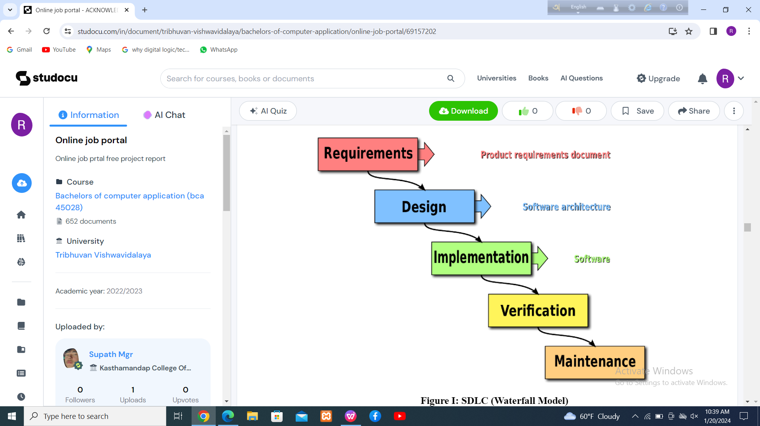

SDLC (Waterfall Model)

REFERENCES:

[1] Techlekh, "Techlekh," TechLekh, 13 February 2018. [Online]. Available:

https://techlekh.com/nepali-job-portals/. [Accessed 1 january 2019].

[2] GadgetByte, "GadgetByte," 13 may 2018. [Online]. Available:

https://www.gadgetbytenepal.com/best-job-portals-nepal/. [Accessed 15 january 2019].